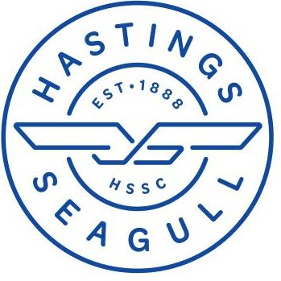

Hastings Seagull Swimming club
Terry Fitzgerald Memorial Meet 22nd June 2024
Level 3 - License 3SE240088
Summerfield Leisure Centre
Hastings TN34 1ET

SUMMARY SHEET
Please complete sheet details and email along with copy of your HyTek file to : meetsecretary@hastingsseagullsc.org.uk
 |  | Calculate Total Cost
Number of entries (@£7) | (a) | (A) £
Number of coach passes (@£25) | (b) | (B) £
Total Cost (A+ B) |  | £

Name of club
Name of club officer submitting entries
Preferred contact number
Email address of club office

Please pay online once you have received your accepted entry list
Hastings Seagull Swimming Club
Account Number: 12300427 Sort Code: 40-23-18

